Detection of small covert networks embedded in large networks

Carl Pearson¹ Edo Airoldi², Edward Kao², Burton Singer¹

¹University of Florida, Emerging Pathogens Institute, Gainesville, FL
²Harvard University, Statistics, Cambridge, MA

ABSTRACT

We specify and test a simulation model for identifying small partially observable covert networks embedded in large networks containing many sub-networks that represent a background of clutter. The covert network is planning a coordinated action that requires rapid identification. Instructions and details of the plan are transmitted in fragments from a coordinator, but each fragment, by itself, is insufficient to identify a suspicious plan. We examine a diversity of sequential strategies to be employed by an external observer for sampling message transmission in the large network and passively identifying the target covert network in minimum time. Scenarios where members of the covert network send out decoy signals and where the observer employs deceptive messaging as part of a sequential search strategy are also considered. Depending upon the levels of mutual deception by the covert network and the observer, identification of the full target network may be impossible. We characterize such situations and then indicate the largest sub-network of the covert group that is identifiable with confidence. Such identification is used to signal when action should be taken against a coordinated scheme. More generally, we explore trade-offs between information available to an observer/experimenter and ability to confidently detect suspicious activity.

- INTRODUCTION

The structure and dynamics of the covert networks we consider is based on extant evidence about the characteristics of the global Salafi jihad as documented in Sageman¹.
The overall architecture is controlled by a relatively small collection of key individuals with close links to a larger group of lieutenants who essentially guide the planning of specific terrorist events. These lieutenants act as hubs (H) for an international set of sub-networks that are essentially of two broad kinds: small world networks and strongly hierarchical networks. In the present discussion, we focus on small world networks Because of the presence of cliques, or approximate cliques, as the most primitive modular units for collectivities that implement terrorist events, we constrain the overall covert network to be a small world network with small distance between members and a high degree of clustering (Barmpoutis and Murray²). Interaction between members of approximate cliques is intense, face-to-face, and unobservable via monitoring of one or more forms of communication among members of a large network within which the covert network is embedded. The larger network contains multiple sub-networks that we view as clutter, as well as randomly generated dyads, triads, and larger collectivities, most of which are not associated with the covert network of interest.

Detectable communication between H and the approximate cliques -- the set of which comprise the covert network -- that will be involved in a terrorist event is via non-reciprocal transmission of key message fragments to one, or possibly two or three, members of each approximate clique. These messages are all of short duration relative to many of the transmissions involving H and members of the larger network. Within-approximate clique communication about the key message fragments is face-to-face.

Based on Sageman’s review of terrorist network structure (Ref. 1, chapter 5), the coarsest level of transmission of messages through a large network via, for example, cell phones should exhibit the following characteristics relative to H and the members of approximate cliques (the overall covert network) who are implementers of terrorist events:

a. H should have high in-degree and out-degree -- i.e. H should be in the upper tail
of both degree distributions.
b. Members of approximate cliques should have low in-degree and still lower out-
degree. They are relatively isolated from the surrounding society, but communicate
intensively with each other mostly on a face-to-face basis. This close
communication is not observable from cell phone traffic.
c. H to clique transmission consists of multiple messages, widely distributed in time,
and focused on implementation of a terrorist event. There is, with very rare
exception, no clique to H transmission of either harmless or event-related
messages. Thus, identification of candidate Hs from the larger network should
seek high out-degree persons for whom an important sub-set of their outgoing
messages are never reciprocated by the receiver.
d. There is some low frequency communication between one or more members of
two different approximate cliques. Thus, two individuals who are on the receiving
end of event-related communication from H can be assumed to be in different
approximate clique if they communicate either event-related or non-event-related
messages, or both, with the non-event-related messages reciprocated over
relatively short intervals of time.

In- and out-degree information alone is not enough to identify one or more Hs and the relevant cliques. The full plan of a terrorist event is distributed over multiple special messages. Thus, it is the accumulation of these special messages by approximate clique members that signals them as a likely terrorist group. Individual special messages can also transmitted among various dyads or even within other sub-networks where they have meaning that is quite different from being a component of event instructions. Intermixed with special message traffic -- indeed dominating it -- is general message traffic. H, in particular, is involved in a lot of that as part of his important role in the global Salafi jihad.

2. A SIMULATION MODEL

2.1 The structure of covert networks

We use the 9/11 hijackers as an initial example. Figure 1 shows the entire network, which
consists of the 19 participants distributed among 4 cliques according to the color coding below.

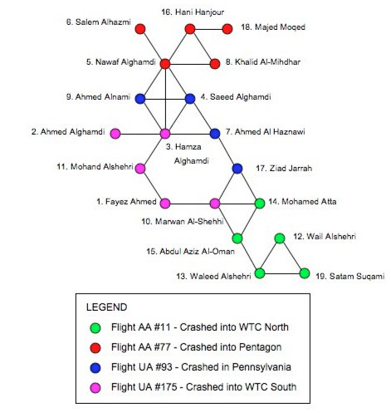

FIGURE 1 -- 9/11 Hijackers with links corresponding to close relationship prior to
planning of the World Trade Center and Pentagon crashes

H for the hijackers transmits event-planning messages to three members of the ‘red’ clique, who in turn distribute them to one member of each of the other cliques as shown in Figure 2.

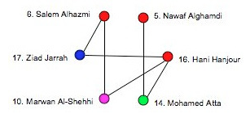
FIGURE 2 -- Transmission of event - planning messages from members of ‘red’ clique
to individual members of the ‘blue’, lavender’, and ‘green’ cliques

This transmission is detectable, in addition to the transmissions from H to the shown members of the ‘red’ clique. Thus, 6 out of the 19 hijackers are identifiable from event-related message traffic. The sizes of the cliques and their membership are not observable from event-related message traffic. Because of the structure of the graph in figure 2, we know that persons numbered 5, 6, and 16 are in the same clique, while 10, 14, and 17 are in different cliques. [NOTE: Figure 2 should be redrawn with directed edges from 6 to 10 and 17, from 5 to 14, and from 16 to 10 and 14]. This kind of structure is a prototype for the event networks we embed in a much larger general network.

2.2 Generation of message traffic

We assume that there are 7 distinct event-related messages, no one of which is adequate to delineate an event plan. Each of these messages alone can be transmitted between dyads in the larger network as part of more general information transfer. In addition to the 7 distinguished messages, individuals anywhere in the overall network can be members of dyads involved in transmission of what we will generically refer to as a ‘good‘ message. The content of ‘good’ messages is, at least initially, not of concern. When message traffic is by cell phone between individuals labeled i and j, we also record the duration of the call, t_{i,j.}

We initiate transmission in a population with N labeled elements, where N = 5000. N‘ individuals are labeled as members of the covert network with N‘ ≪ N. For an initial
illustration, we use the 9/11 hijackers with N’ = 19. We also assume that 1500 individuals are part of calling networks containing from 3 to 15 individuals. Thus, there must be some overlap between calling networks. We label the calling networks within the listing of the total population of size 5000. These calling networks can be viewed as clutter within the larger network. Members of the covert network, with the exception of H are not part of any of these other networks. They can however send messages to a few individuals outside of their own covert network, but such messages will be infrequent.

On any given day we assume that a random x% of the total population will initiate at least one call, where x can be 40, 50, 60, ...., 90. For each individual, i, sampled as a person to make one or more calls on the given day, we assume that i makes k calls with probability p(k), for 1 ≤ k ≤ 10. Let j₁, ... , j_{k} be the labels of the individuals that i calls, and let t_{i,jv} be the duration of the call from i to j_{v}. Let p(G) be the probability that a given call contains a “Good: message. Then label the bad messages B₁, ... , B₇ and assume that they are each transmitted with the same probability, p(B_{l}). Then p(G) = 1 - 7p(B_{l})

Thus, for a given individual on a given day, the sequence of actions in the simulator is:
1. Selection of i in the probability sampling of x% of the population that will initiate
calls.
2. Determination of k via random number generator with probabilities p(k)
3. Specification of any one of B₁, ... , B₇ or G (=Good message) for each call: B_{l} is
selected with probability p(B_{l}) = small fixed probability which is the same for each
such message. Then p(G) = 1 - 7P(B₁)
4. Specification of t_{i,j} for each of the k calls: For any person i who is not in the covert
network, call durations may be selected from a distribution with support on the
interval [.5, 45] where the units are in minutes. If i is in the covert network and
transmitting to a person in another clique, BAD messages last at most 1 minute,
while GOOD messages have duration selected from the same distribution as
everyone else.

The i → j dyad, the type of message transmitted, and the call duration are entered in a daily call log. H is treated like any other individual except that he releases B₁, ..., B₇ on apriori designated days to the three members of the ‘red’ clique. They pass on these messages to the blue, lavender, and green cliques on widely spaced designated days and via calls of length 1 minute. Otherwise, all clique members are treated like everyone else except that there is no within-clique calling. An overall system diagram for message traffic and storage of daily logs is shown in Figure 3.

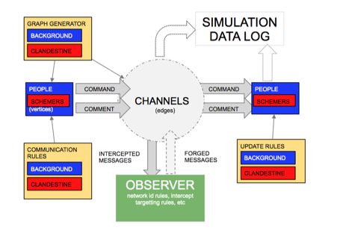
FIGURE 3 -- Simulation System Diagram

2.3 Strategies for Detection of the covert network

< This section will follow by 4 - 3 -2013>

